CS-114 - Fundamental of Programing

Lab #02

**Course Instructor:** Dr Jawad Khan

# Lab Instructor: Muhammad Affan

**Student Name:** Muhammad Ali Shahzadah (section B)

**CMS ID:** 466353

**DATE:** 10/03/2023

**Lab Manual # 02**

**Objective:**

This assignment is about familiarization with using conditional statements.

**Task 1:**

Create a program that takes a student's score as input and assigns a grade based on predefined criteria using logical operators (e.g., A, B, C, D, F).

A-Grade: 90-100 Marks

B-Grade: 75-90 Marks

C-Grade: 60-75 Marks

D-Grade: 45-60 Marks

F-Grade: 0-45 Marks

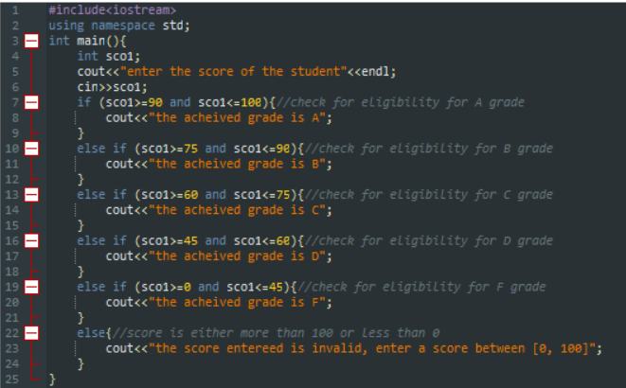

Output:

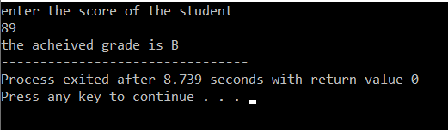

**Task 2:**

Write a program that takes an integer as input and determines if it is both even and divisible by 5. 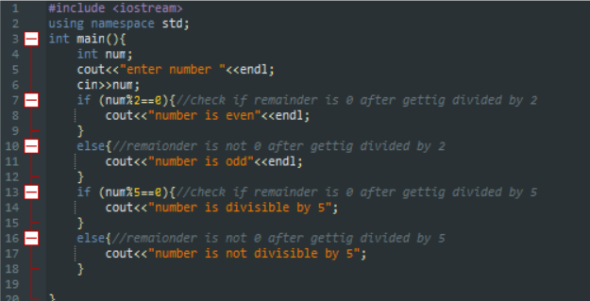

Output:

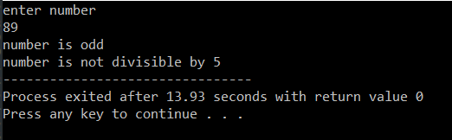

**Task 3:**

Create a C++ program that checks if a user-provided year is a leap year.

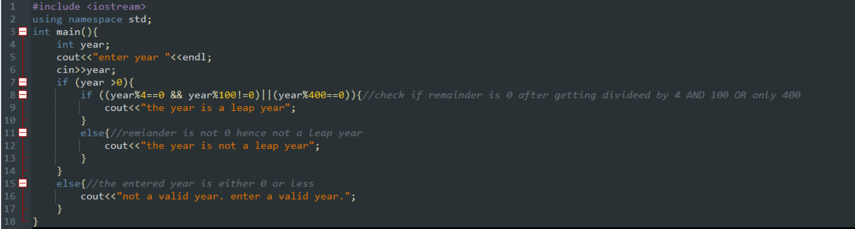

Output:

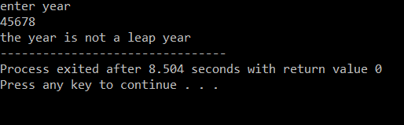

**Task 4:**

Create a C++ program that determines if a student is eligible for a scholarship based on their GPA (must have GPA >= 3.5) and attendance (must have attended at least 80% of classes). 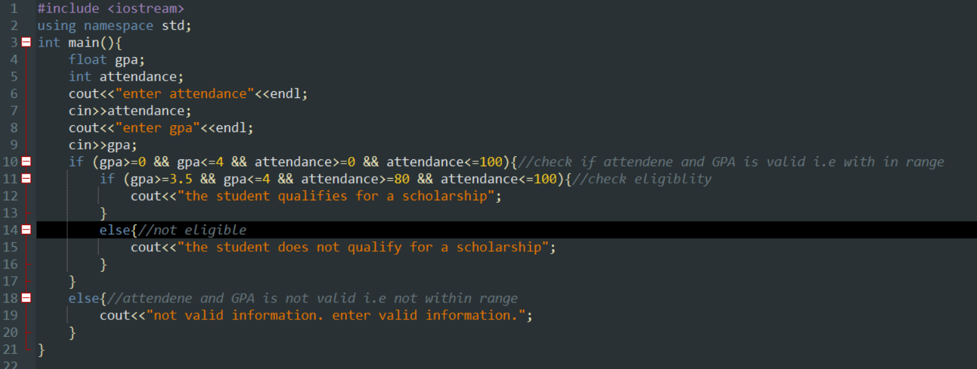

Output:

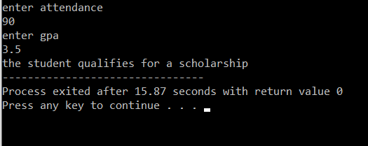

**Task 5:**

Write a program that checks if a given character is a vowel (a, e, i, o, u) or a consonant using logical operators.

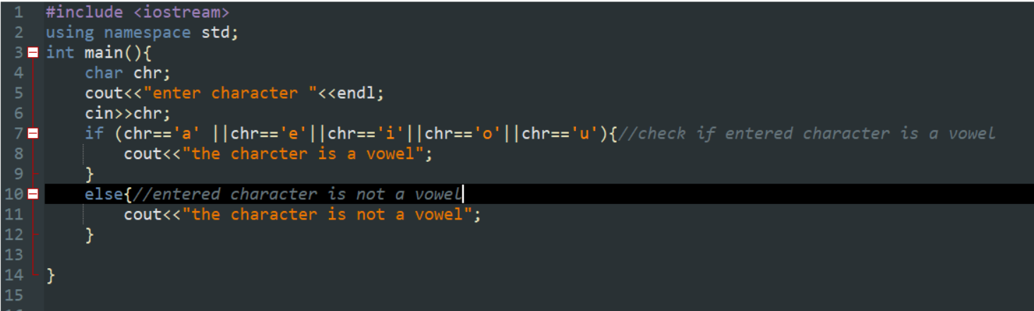

Output:

